Activity 1 - Getting familiar with Google Colab

**Activity goal:**  
Our goal for this activity is to explore the environment and learn how to import a file from your local system to the Colab environment.

**Files used:**  
admissions.xlsx

**Activity Steps:**

1. Open [Google Colab](https://colab.research.google.com/) in a browser.
2. Login to your gmail account so that you can save your work into google drive.
3. Go to File > New Notebook to create a new Python notebook.
4. Click on the name of the file to rename it to something else as shown:  
     
   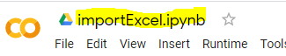
5. To import a file from the local computer, follow the steps as shown.   
   Note: do not worry about the programming aspect of Python yet – we will learn it in the class.
6. Type the following two import commands in the Jupyter notebook and click the play button to execute:  
     
   import numpy as np

import pandas as pd  
  
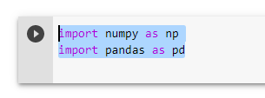

1. Notice that the execution of the commands spins up a VM and assign resources in the colab environment.  
     
   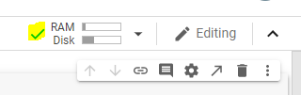
2. Type the following commands, highlight, and execute as shown. Once executed, the Choose file option appears as shown.  
   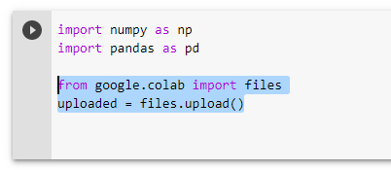

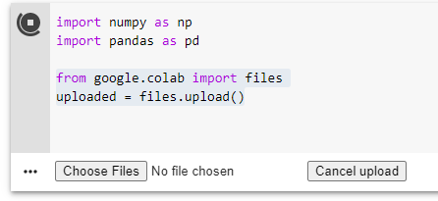

1. Browse to the admissions.xlsx file provided. Once uploaded, you will see the following:  
     
   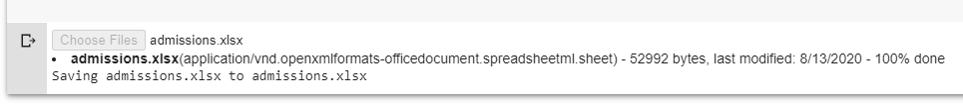
2. Next, we will read from the file to confirm successful load. To read from the file, type the following command and execute.  
     
   import io

df = pd.read_excel(io.BytesIO(uploaded['admissions.xlsx']))

df

1. Alternatively, you can type the whole program in a notebook and run.  
     
   import numpy as np

import pandas as pd

from google.colab import files

uploaded = files.upload()

import io

df = pd.read_excel(io.BytesIO(uploaded['admissions.xlsx']))

df

1. Now that the file is read into a dataframe ‘df’, you can use the df handle to perform additional work.  
     
   